Task 1:

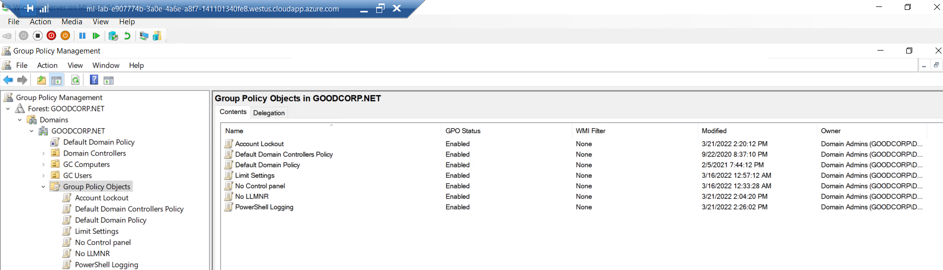

Task 2:

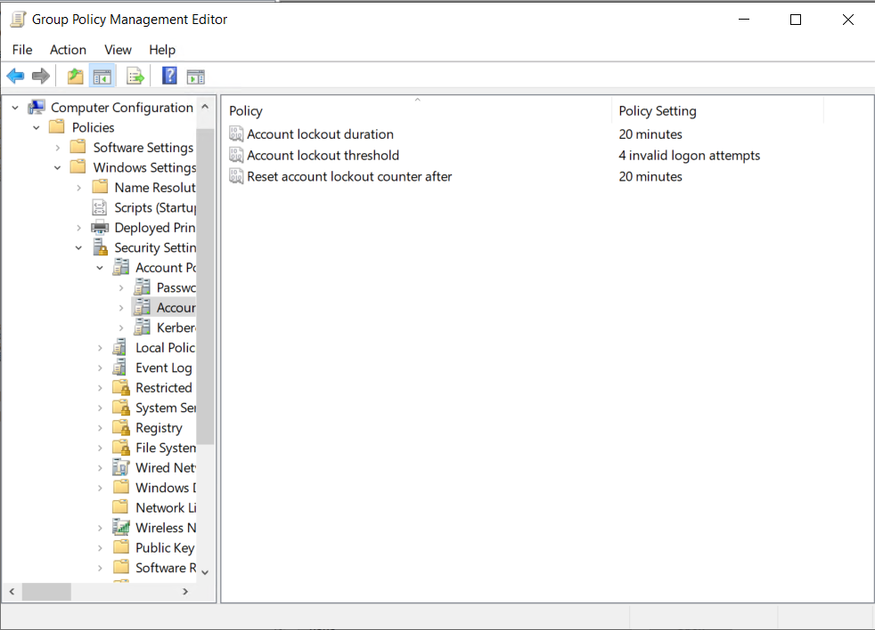

Task 3:

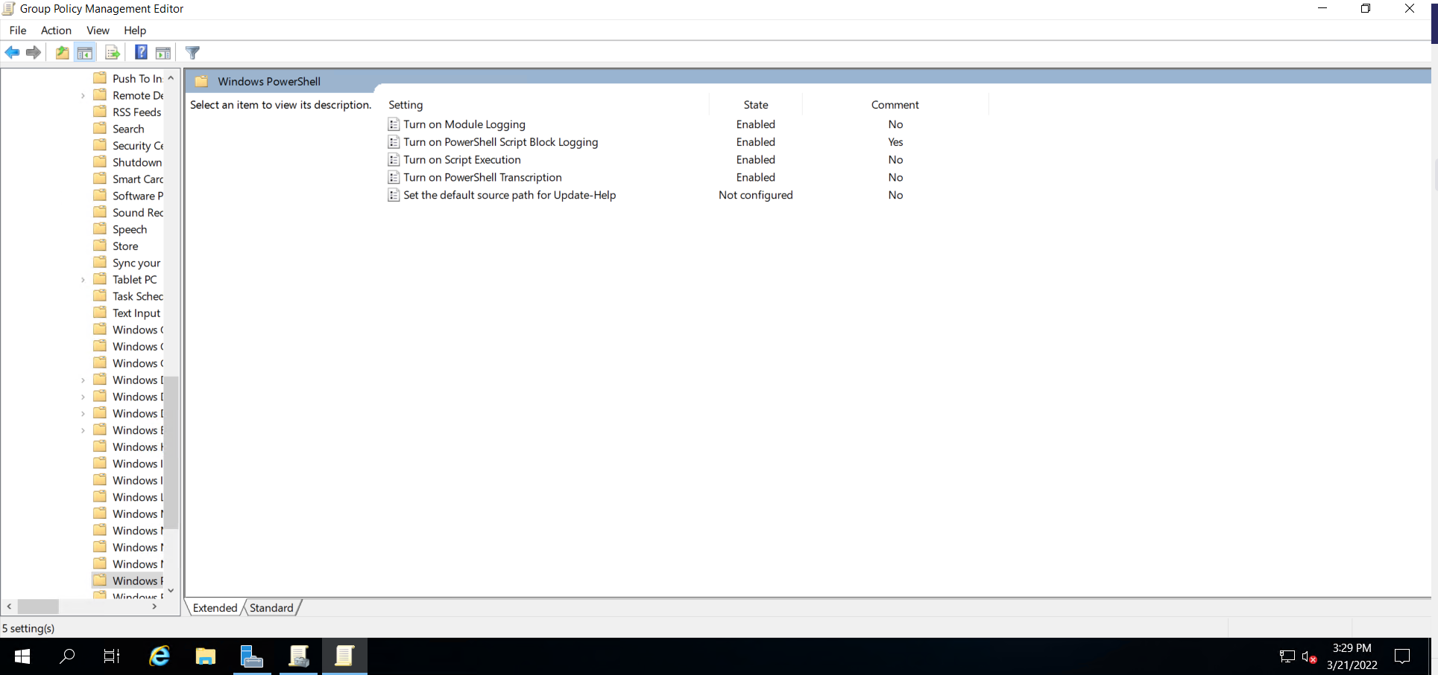

Task 4:

$directory = $(Get-ChildItem)

foreach ($item in $directory) {

Get-Acl $item

}